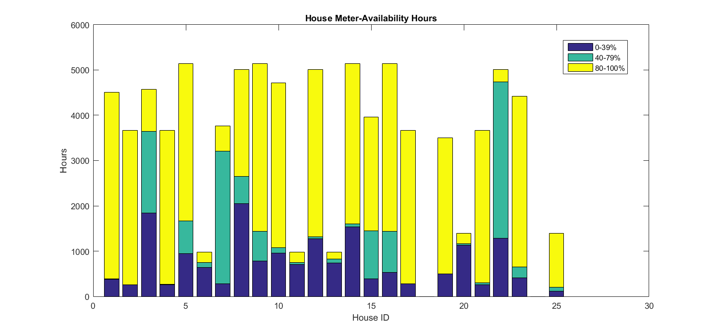

On the above graph is the meter availability shown for each house. The meter availability is a metric telling how many meters had more than 80% of their samples in a given hour.

Meter density describes how many meters is installed and running at a given time. Meter availability for a given hour is found by taking the number of meters that have more than 80% of their samples intact, in the given hour, and dividing it with the meter density, in the given hour.

Some of the houses have fewer hours in total, indicating that there have been times where the meter density is zero, and no meters have therefore given any data.